# Non-Linear Circuit Analysis Modelling of a Diode

The representation of any device with equivalent circuit elements such as resistors, voltage source, capacitor, etc. without loss of its exact functional behavior is called modelling of a device.

## IV Characteristics of ideal diode

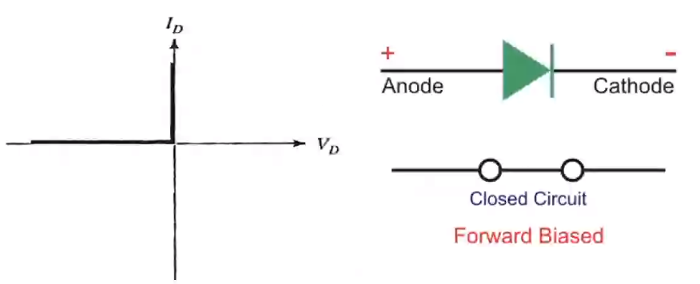

## Linear vs non-Linear Diode

Ideal diode 🡪 short circuit

Constant voltage-drop 🡪 voltage source (0.7v for silicon, 0.3v for germanium)

Piece wise linear modelling 🡪 voltage source + ideal diode + resistor